Project Design Phase
Solution Architecture

Date | 30 September 2026
Team ID | SN-TRANSFORM-01
Project Name | Import Data using Transform Maps (Spreadsheet)
Maximum Marks | 4 Marks

Solution Architecture:
The proposed architecture bridges the employee-import problem to a controlled ServiceNow solution. It separates file intake, staging, transformation, target storage, duplicate prevention and reporting so each step can be validated.
- Accept employee spreadsheet rows through the ServiceNow Load Data interface.
- Stage raw rows in Employee Import before changing target records.
- Use Sample Spreadsheet Import and Mapping Assist to map fields into Employee Test.
- Coalesce on Employee ID so repeat imports update, insert or ignore records predictably.
● Expose transform history, reports and Employee Analytics Dashboard for operational monitoring.
ServiceNow Employee Import Architecture:

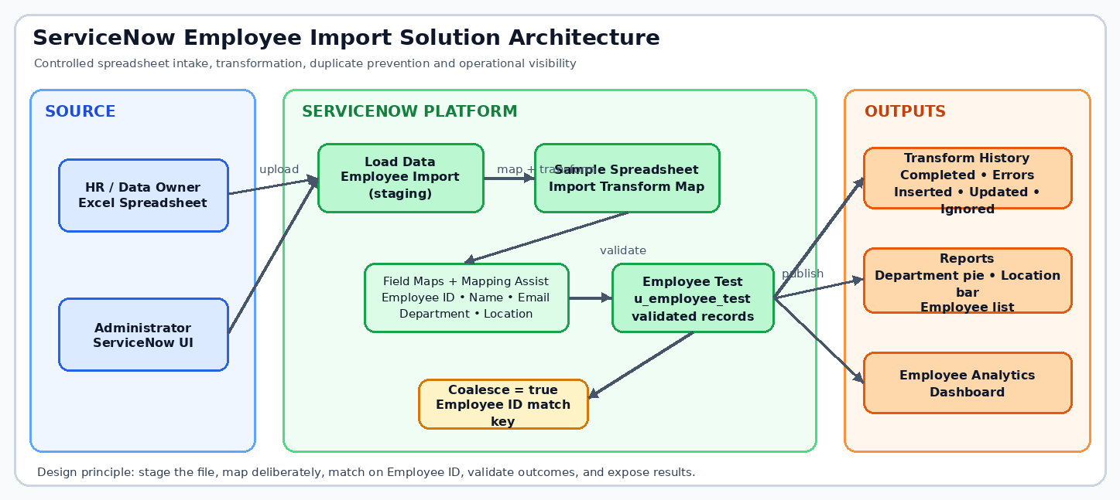
Figure 1: Architecture and data flow of the ServiceNow employee spreadsheet import solution
Reference: Project brief — Import Data using Transform Maps (Spreadsheet)

